

Disabled people’s extra burden of essentials
  - A WPI Economics report for Scope

Matthew Oakley - Director - matthew@wpieconomics.com
Naoko Skiada - Senior Data Insights Analyst
Matthew Tibbles - Consultant
Edward McPherson - Senior Consultant

February 2024

ABOUT WPI ECONOMICS
Founded in 2016, WPI Economics makes an impact through economics that people understand, policy consulting and data insight. We work with a range of organisations – from FTSE 100 companies, to SMEs, charities, central and local government – to help them influence and deliver better outcomes through improved public policy design and delivery.
Our focus is on important social, environmental and economic policy debates, such as the future of the green economy, productivity and growth, levelling up and mental health. We are driven by a desire to make a difference, both through the work we do and by taking our responsibilities as a business seriously. We are a Living Wage employer, currently working towards BCorp accreditation.

ABOUT SCOPE
We’re Scope, the disability equality charity. We won’t stop until we achieve a society where all disabled people enjoy equality and fairness. At home. At school. At work. In our communities.
We’re a strong community of disabled and non-disabled people. We provide practical and emotional information and support when it is needed most. We use our collective power to change attitudes and end injustice.
We campaign relentlessly to create a fairer society. And we won’t stop until we achieve a society where all disabled people enjoy equality and fairness.

Disclaimer and legal
This report has been produced by WPI Economics, an independent economics, policy and data insight consultancy. The views expressed in the report are based on independent research and represent solely the views of the authors. They are provided for informative purposes only.
Whilst we undertake every effort to ensure that the information within this document is accurate and up to date, neither WPI Economics nor the report’s authors accept any liability for direct, implied, statutory, and/or consequential loss arising from the use of this document or its contents.

SUMMARY OF FINDINGS

Disabled people face an extra burden of essentials
This report demonstrates that disabled people have to allocate a higher proportion of their overall spending to paying for essentials. This “extra burden of essentials” for disabled people matters: alongside the spending required on additional items that disabled people might need, it reduces the amount that they are able to spend on discretionary items, which in turn impacts negatively on their living standards.
The extra burden of essentials comes from several different living costs, but in particular from higher proportions being spent on energy and food. The cost-of-living crisis has also led to large increases in the cost of essentials, meaning that, with budgets already more heavily focussed on these essentials, disabled people have been impacted particularly badly.

Key findings include:
- Households that include at least one disabled person have to allocate a higher proportion of their overall spending to everyday essentials. For example, low-income households that include a disabled person allocate 62.9% of their total spending to non-housing essentials, compared to 60.3% for households that do not include a disabled person.
- Between the start of the pandemic and July 2023, the average cost of the basket of essential goods bought by households that include at least one disabled person would have increased by 31%. So, if these households had maintained their spending patterns on essentials over the course of the pandemic – they would have to be spending £59 more per week in July 2023 than they were before the pandemic.
- Taken together, and after controlling for the differentials in demographic characteristics, higher shares of budgets going to essentials and higher inflation impacts mean that compared to non-disabled households, households that include a disabled person face an average additional burden of essentials of around £12 per week in 2023. This is equivalent to an additional £625 per year that must be allocated to essentials; money that would otherwise be available to be spent on additional disability-related costs and discretionary items.
- The overall impacts of this on poverty are significant. Were the extra burden of essentials accounted for in the Social Metrics Commission’s measure of poverty, an additional 245,000 people – disabled people, and those living in families that include a disabled person – would be counted as living in poverty.

Tackling the extra burden of essentials would raise living standards amongst disabled people
We have created a range of scenarios to assess what impact reducing the extra burden of essentials would have on the living standards of disabled people.
It is, though, important to remember that the extra burden of essentials is just one element of the extra costs faced by disabled people. Our analysis does not consider the extra needs that disabled people have (e.g. for adaptations or aids) or assess the overall impact of disability on living standards. Scope’s existing work, The Disability Price Tag, covers many of these issues and reports estimates of the overall costs of disability far in excess of the estimates in this report. For this reason, our policy analysis also assesses the potential impacts of going further and tackling at least part of the overall extra costs faced by disabled people.
Key scenario findings include:
- Reducing the extra burden of essentials by £12 per week for all households that include a disabled person would mean a total reduction in costs of £4.5bn a year for these households. It would reduce poverty amongst disabled people and those living in a family that includes a disabled person by 285,000 and deep poverty by 205,000. Reducing it by £20 per week would see poverty fall by 510,000 and deep poverty by 335,000.
- Reducing the extra burden of essentials by £12 per week for all households that include a disabled person who are also in the bottom two unequivalised income quintiles would mean a total reduction in costs of £2.5bn a year for these households. It would reduce poverty amongst disabled people and their families by 180,000 and deep poverty by 175,000. Reducing it by £20 per week would see poverty fall by around 310,000, and deep poverty fall by 300,000.
- An approach targeting a £12 per week addition for Personal Independence Payment (PIP) / Disability Living Allowance (DLA) claimants would mean a total increase in benefit payments of £1.7bn a year for disabled people. It would reduce poverty amongst this group and their families by 115,000 and deep poverty would fall by 80,000. Increasing it by £20 per week would see poverty fall by 205,000 and deep poverty 105,000.

What should we do about it?
These impacts could be delivered through a range of approaches, including those that provide support through the social security system and those that either seek to reduce the price of essentials, or the amount that disabled people need (e.g. reducing the energy needs of households that include a disabled person, by improving the energy efficiency of these households). The former would only provide support to those already claiming benefits (unless eligibility criteria were changed, or take up further increased). The latter could be targeted across all disabled people, or at specific (e.g. low income) groups of disabled people.
In considering the approach which is likely to be most effective, we have drawn on two key conclusions from our work:
- The fact that an extra burden of essentials remains for households that claim extra cost benefits (DLA/PIP) even after accounting for the money received from the benefits, shows that these benefits are currently insufficient to meet the extra burden.
- The existence of an extra burden of essentials amongst those who do not claim benefits and / or extra cost benefits specifically (£10 per week for a household including one disabled person and not claiming benefits), shows that the burden goes much broader than just those already claiming extra cost benefits – so solutions focussed purely on increasing support through the social security system are unlikely to be wholly effective.
Overall, this informs our view that there is not a single approach that will be effective in tackling the extra burden of essentials faced by disabled people. Instead, a package of interventions is likely to be needed. We would put forward the following:
- An additional essentials payment of £10 per week, paid to disabled people in receipt of any disability-related benefit (income based, or extra cost), on top of their existing benefits (with a cost of £2.9bn a year). Should this need to be targeted further, the priority should be those disabled people claiming income-related benefits (e.g. Universal Credit), to ensure that the approach is targeted at those on the lowest incomes (with a cost of £1.6bn). Alongside this, as part of future work to develop a new assessment process for disability benefits, there could be consideration of whether a lower threshold of disability / impairment might be introduced when assessing eligibility for benefits, which gives more disabled people access to just this essentials payment.
- A social tariff for energy for disabled people, like the one already proposed by Scope and other organisations, and linked to a new scheme and support to fast-track retrofitting of disabled people’s homes and take up of smart technology to improve the energy performance rating (noting that upgrading properties currently rated as worse than Energy Performance Certification (EPC) C, to a rating of C or better could mean cost savings of £567 per year to the occupiers of these properties).
More broadly, this report and the methodological approach that underpins it provides new insights and approaches that could be used to improve measurement of poverty (for example, by considering how this might be incorporated into Department for Work and Pension (DWP)’s experimental statistics based on the Social Metrics Commission (SMC)’s measure of poverty) and ensure that yearly increases in disability benefits (e.g. extra cost benefits) better reflect the experiences of inflation that disabled people face. Doing so would ensure that we continue to better understand the impact of the extra burden of essentials on disabled people, and whether current policy responses are sufficient.

CONTEXT
A wide body of evidence has demonstrated the extra costs that disabled people face compared to households that do not include a disabled person. These are wide-ranging, and include:
- The need to buy different things. Compared to households that do not include a disabled person, disabled people need to buy different things to meet their day-to-day needs. For example, this might include aids and adaptations, or to pay for taxis because public transport is inaccessible.
- The need to buy more of some things. For example, if compared to non-disabled people, disabled people need to keep their homes heated for longer, or to a higher temperature, they would need to spend more on energy.
- Having to pay more for some things. For example, some forms of insurance (particularly travel insurance) cost more for disabled people.
Understanding these extra costs is vital for measuring living standards, wellbeing and life experiences of disabled people. For example, the Social Metrics Commission has shown that, after including a measure of the extra cost of disability, around half of all people in poverty in the UK (50%) are disabled, or live in a household that includes a disabled person. A range of recent research has also pointed towards potentially significant impacts of the cost of living crisis on disabled people.
More broadly, the extra costs that disabled people face contribute to the fact that disabled people and their families experience a lower standard of living than otherwise equivalent families with the same level of income. Previous research from Scope has quantified the financial scale of this differential in standards of living. It showed that, on average, for a disabled household to experience the same standard of living as a household that does not include a disabled person, they would need additional income of £11,700 per year.
This research seeks to build on these different analyses and to dig deeper into the extra costs faced by disabled people. We focus on one part of the overall extra costs that disabled people face; the extra burden of essentials faced by households that include a disabled person, or the extent to which disabled people have to allocate a greater proportion of their spending to essential items, leaving less left over for discretionary spend. We explore how this impacts on households that include a disabled person and whether existing policy and financial support mechanisms mitigate these impacts. We then outline areas where Government and others could make a difference.
To consider this, our research has focussed on five key questions:
- How is spending by disabled people different to non-disabled people and is there an extra burden of essentials?
- How have recent changes in inflation, particularly during the cost-of-living crisis, impacted on disabled people and their spending?
- How does the extra burden of essentials impact on poverty and other outcomes for disabled people?
- What difference would reductions in the extra burden of essentials have on rates of poverty amongst people living in a family that includes a disabled person?
- What does all of this say about how the extra burden of essentials could be most affectively reduced?

SECTION 1: How is spending by disabled people different to non-disabled people and is there an extra burden of essentials?
Our work to understand the differences in spending between disabled and non-disabled people has used the Living Costs and Food Survey (LCFS); an annual survey of around 6,000 UK households, designed to allow a detailed record of spending to be captured and analysed. To ensure we had a sufficient sample to provide robust analysis, we pooled three years of data up to 2019/20. Annex 2 provides more technical details of our work using the LCFS.
Overall, analysis of the LCFS shows that, compared to households that do not include a disabled person, there are significant differences in what households that include at least one disabled person spend their money on. For example, in 2019, households that include at least one disabled person spent:
- A higher proportion of total spending on food and non-alcoholic beverages (16.8% compared to 13.3%); and
- A higher proportion on energy (8.0%, compared to 5.7%).
Whilst some of these differences might seem small, in financial terms they are meaningful. Applying them to average spending shows that a 3.5 percentage point difference in spending on food could amount to some £965 over the course of a year. For energy, the 2.3 percentage point difference in spending amounts to £12.18 per week, or the equivalent of £634 over the course of a year.

Figure 1: Proportion of total spending for categories where households that include at least one disabled people spend a higher proportion of overall spending, compared to households that do not include a disabled person
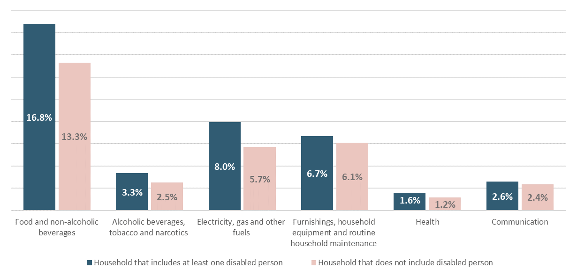
Source: WPI Economics analysis of LCFS, three years of data pooled up to 2019/20

Of course, differences in spending patterns between disabled people and non-disabled people are driven by a range of different factors. For example, a large part of the differences could be due to the fact that disabled people have, on average, lower incomes. To seek to understand this in more depth, we conducted the same analysis, but this time splitting the results to compare disabled and non-disabled people in the same household groups looking at the equivalised income quintiles.
The results are shown in figure 2. The bars show the differences in spending compositions between disabled and non-disabled people in the same equivalised income quintile. Where the number is positive, it means that disabled people allocated a higher proportion of their spending on this category, as compared to non-disabled people in the same equivalised income quintile. For example, it shows that disabled people in the bottom income quintile allocated 2.4 percentage points more of their spending to energy than non-disabled people and 3.5 percentage points more to food and non-alcoholic beverages.
Overall, these results show that disabled people typically allocate a higher proportion of their spending to food and beverages, energy, general household spending and health.
Figure 2: Difference in spending (as a proportion of total spending) for disabled people, by equivalised income quintile
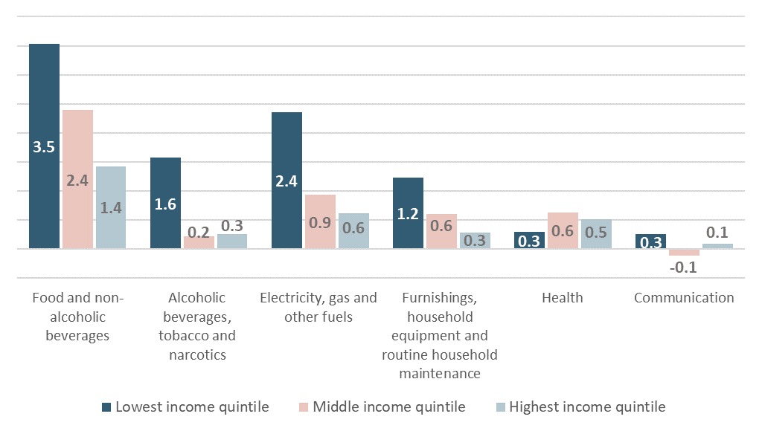
Source: WPI Economics analysis of LCFS

Another way of looking at these differences is to consider how spending divides between essential and non-essential items for disabled and non-disabled people. To do this, we classified products and services as essential or non-essential based on an innovative approach developed by the Australian Bureau of Statistics. This provides a significant level of detail on the essentials that households need and applies these to the spending categories available to us in the Living Costs and Food Survey, allowing us to conduct this detailed analysis. Here we use an after-housing-costs measure of essentials, to ensure that our results are applicable to the Social Metrics Commission’s measure of poverty (see below and Annex 2).
Based on this approach, we see that disabled people allocate significantly higher proportions of their total spending to items classed as essentials. For example, in 2019, disabled people in the lowest income quintile allocated 62.9% of their total spending to essentials, compared to 60.3% for non-disabled people. This 2.6 percentage points difference equates to the equivalent of £390.48 of yearly spending for disabled people in the lowest income quintile. In living standards terms, this extra burden of essentials matters. It means that disabled people are only able to allocate a smaller proportion of their overall budgets to discretionary spending – things that to enhance living standards and quality of life.
Figure 3: Proportion of total non-housing spending that is allocated to essentials for households that include at least one disabled person, and those that do not
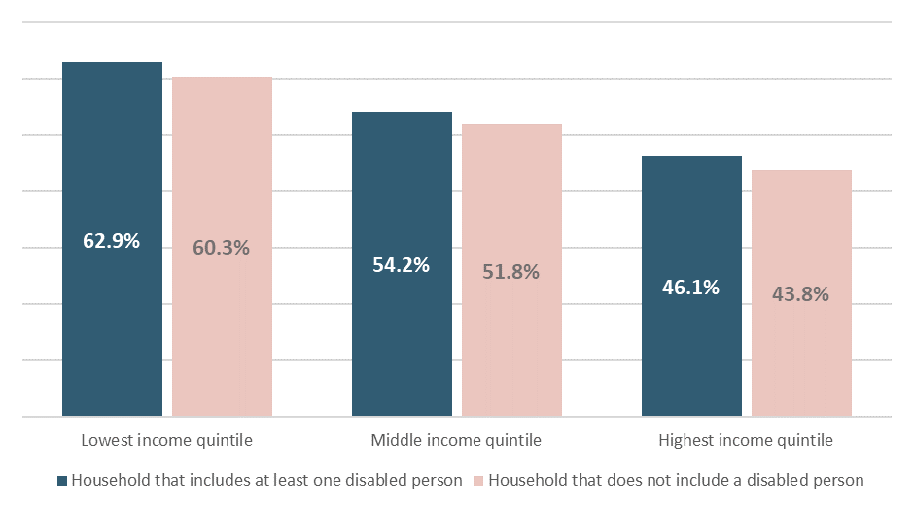
Source: WPI Economics analysis of LCFS
Notes: Analysis is “non-housing”, in that it excludes mortgage and rent payments, see technical annex for explanation. All other costs of housing are included.
In this respect, this extra burden of essentials is one element of the overall extra costs of disability. However, there are other elements that should be considered in a fuller analysis. For example, our approach does not account for additional needs that disabled people have but cannot fulfil because they cannot afford to meet them. There are also other reasons why disabled people might need higher levels of incomes to achieve a similar standard of living as non-disabled people. These factors are captured in Scope’s existing work on the Disability Price Tag.

SECTION 2: How have recent changes in inflation, particularly during the cost-of-living crisis, impacted on disabled people and their spending?
Challenges with collecting robust survey data during the COVID-19 pandemic, mean that the latest robust data we have on detailed spending choices of UK households comes from before the pandemic. That means that all the results presented so far have focussed on the situation prior to the pandemic. However, we also know that the subsequent cost-of-living crisis has driven significant changes in prices, particularly for essentials. These changes have been shown to have impacted most on those with the lowest incomes and who are least able to shoulder the additional burdens.
As such, given the differences in spending composition and, in particular, the additional spending allocated to essentials for disabled people, an important part of this analysis has been to consider how the cost-of-living crisis might have impacted on the results above. To do this, we have used an approach that we have developed to apply detailed estimates of inflation for different spending categories to the baskets of goods that households bought prior to the pandemic. This allows us to consider the “inflation impact” on different households; or what the basket of goods they bought prior to the pandemic might have cost if they had bought the same goods in 2023. The broad approach is summarised in figure 4.

Figure 4: Summary methodology for determining “inflation impact”
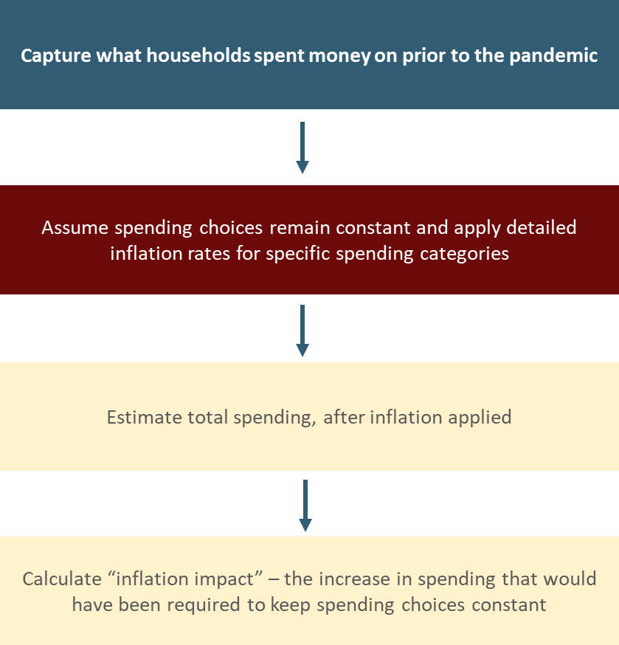
Source: Adapted from WPI Economics for Trust for London

The first thing to note is the scale of the cost-of-living crisis for disabled people. Overall, our analysis shows that if they maintained the same spending patterns as before the pandemic, the average cost of the basket of goods bought by disabled people would have increased by 26%.
The cost of essentials has also risen more quickly than for non-essentials. Just focussing on essential spending shows that, if disabled people had maintained their spending patterns on essentials over the course of the pandemic – they would have to be spending 31% (£59) more per week in 2023 than they were before the pandemic. That’s the equivalent of an annualised spend of around £3,082 a year.
Overall, the comparatively large proportion of spending that disabled people allocate to essentials also means that disabled people have seen a bigger impact of the cost-of-living crisis over the last three years than non-disabled people. On average, over the last twelve months, overall inflation impacts have been 1.7 percentage points higher for households that include a disabled person, compared to those that do not.
Figure 5: Percentage increase in the cost of 2019/20 essentials baskets bought by households, by whether the household includes a disabled person
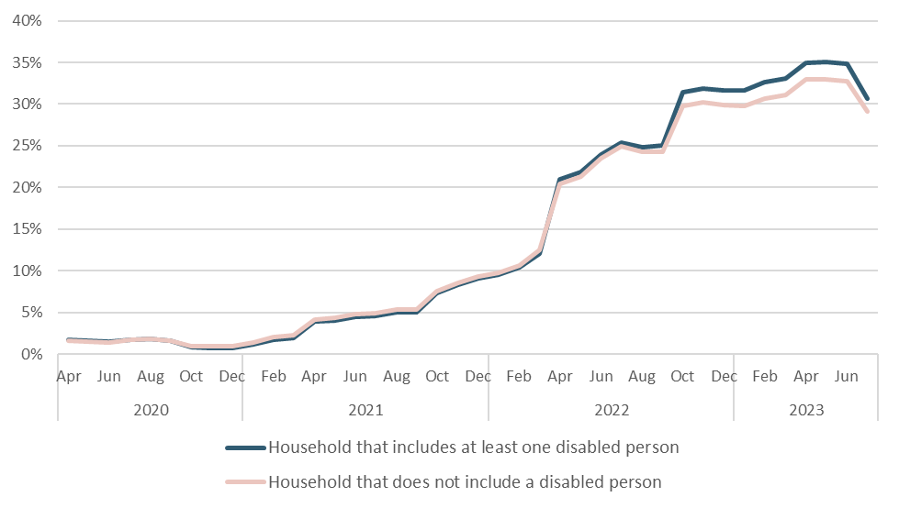
Source: WPI Economics analysis of LCFS

SECTION 3: How does the extra burden of essentials impact on poverty and other outcomes for disabled people?
This first section in this report identified an extra burden of essentials faced by disabled people. To understand the extra burden of essentials better, we also need to account for the fact that the average characteristics of households that include a disabled person are significantly different to those that do not include a disabled person. These differences are likely to mean that, even within households with similar incomes, spending baskets will vary because needs will also vary.
To account for this, we undertook regression analysis that analysed the extra burden of essentials for disabled people and sought to control for the range of differences in demographic characteristics we see between households that include a disabled person, and households that do not. Our analysis also split households that include a disabled person by the number of disabled people within the household, whether they claim benefits and broad category of benefits claimed (see Annex 2 for more detailed of the methodology).
As we have used data from collected before the pandemic, in order understand the impact of the differential rates of inflation, we have also adjusted our estimates of the extra burden to account for the differential in inflation impacts faced by disabled people and the general rate of CPI since then.
On average, this means that the extra burden of essentials faced by households that include a disabled person amounts to £12 per week (£625 annually). Figures range from £9.50 per week (equivalent annual value of £495) for households that include one disabled person and who are claiming benefits that include an extra cost benefit, through to £20 per week (£1,040 annual equivalent) for households that include one disabled person and are claiming income-replacement benefits, but not extra cost benefits.
Table 1: The extra burden of essentials for households including at least one disabled person
 | £ / week extra burden of essentials | Equivalent yearly value
Household with one disabled person, not claiming benefits | £9.50 | £495
Household with multiple disabled people, no benefits | £16.50 | £860
Household with one disabled person, claiming income-based benefits only | £20.00 | £1,040
Household with multiple disabled people, claiming income-based benefits only | £9.50 | £495
Household with one disabled person, claiming benefits including extra cost benefits | £9.50 | £495
Household with multiple disabled people, claiming benefits including extra cost benefits | £13.50 | £700
Source: WPI Economics analysis of LCFS
Notes: Figures rounded, so may not sum exactly between weekly and yearly equivalent values
These additional costs faced by disabled people have a real impact; they reduce the amount disabled people are able to spend on discretionary items and form an important part of understanding the overall extra costs of disability. To understand how this impacts on the financial situation of disabled people, we have adapted the Social Metrics Commission (SMC)’s measure of poverty to incorporate our estimates of the extra burden on essentials. This measure of poverty is currently an official statistic in development, with work being taken forward by the Department for Work and Pensions.
The measure was developed to allow for a better understanding of poverty, beyond just looking at incomes. It does this by accounting for the costs of housing and childcare and starting to consider the extra cost of disability. It also includes an assessment of the liquid assets that families have available to them. While the measure deliberately leads to a similar number of people in the UK in poverty as the regularly-used relative low-income measure provided by the Households Below Average Income statistics, these adaptations lead to a significantly different composition of poverty. Of most relevance for this research, the inclusion of an account of the extra cost of disability are part of the reason why half (50%) of all people in poverty under the SMC measure are disabled, or live in a family that includes a disabled person.
While the SMC’s measure marks a step forward in understanding poverty amongst disabled people, its measure of the extra cost of disability is not a direct one. In fact, because of a lack of available data on the extra cost of disability within the Family Resources Survey (a household survey of around 24,000 households, that is predominantly used to measure poverty within the UK), the SMC’s measure assumes that the extra costs of disability are equivalent to the value of extra cost benefits that a household receives.
This was a simplifying assumption made at the time of the Commission’s launch in 2018 that, in effect, ensures that income from extra-cost benefits is not assumed to be able to meet the wider day-to-day needs of disabled people. The Commission has also recommended that further work should be undertaken to provide a more accurate assessment.
In this respect, our results here show two important things:
- Disabled people who do not claim extra cost disability benefits also experience an additional burden of essentials. The SMC measure implicitly assumes that, unless claiming extra-cost disability benefits, disabled people face no additional costs of disability. This could lead to a systematic underestimation of poverty amongst disabled people who do not claim Disability Living Allowance (DLA) / Personal Independence Payments (PIP).
- For those claiming extra cost benefits, the additional burden of essentials is still present even after accounting for this income. This suggests that, on average, the additional costs faced by disabled people claiming extra-cost disability benefits exceed the current value of those benefits. This could lead to a systematic underestimation of poverty amongst disabled people who do claim DLA / PIP.
With these two factors in mind, our approach uses the estimates of the extra burden of essentials for different groups of disabled people (from the Living Costs and Food Survey) and then allocates the financial value of these extra burdens to disabled people in the FRS. We then conduct analysis of poverty, with and without the extra burden included.
The results show that the inclusion of the extra burden of essentials:
- Raises the poverty rate amongst disabled people by 1.6 percentage points to 41.0%.
- Increases poverty amongst disabled people and those living in a household that includes a disabled person by 1.6 percentage points to 37.7%.

Table 2: Impact of the extra burden of essentials on poverty amongst disabled people
 |  | SMC poverty measure |  | SMC poverty measure after including extra burden of essentials
 | Total number (working age & children) | Number in poverty | % in poverty | Number in poverty | % in poverty
Disabled people | 8,475,000 | 3,335,000 | 39.4% | 3,470,000 | 41.0%
Disabled people and others living in families that include a disabled person | 15,200,000 | 5,480,000 | 36.1% | 5,725,000 | 37.7%
Source: WPI Economics analysis of LCFS & FRS / HBAI
Notes: Figures may not sum due to rounding

SECTION 4: What difference would reductions in the extra burden of essentials have on disabled people’s outcomes?
The last section demonstrated that the extra burden of essentials increases poverty amongst people living in a family that includes a disabled person by around 245,000. Conversely, this means that, if this extra burden were to be eradicated, poverty amongst this group would fall by the same amount. Section 5 of this report discusses a range of options for how this might be achieved, for example by increasing social security, or by actions that directly reduce the costs of essentials for disabled people.
As described below, the choice of intervention will have implications for those that are supported, as well as for the potential costs involved and the route for implementation. Some measures could apply to all disabled people, others just benefit claimants or disabled people on particularly low incomes. Of course, the extra burden of essentials is also just one part of the overall extra costs of disability, meaning that the overall ambition might be to provide support that goes beyond the eradication of the extra burden of essentials.
This section considers these issues through the lens of poverty, and how reductions in the extra burden of essentials, and wider extra costs of disability, might impact on poverty amongst working-age disabled people and those who live in families that include a working-age disabled person. We considered reductions of £5, £10, £12, £20 and £40.
We apply each of these reductions to a range of scenarios based on where the approach is targeted:
- Towards all disabled people or families that include a disabled person. This approach is used to proxy a reduction in costs that is uniformly experienced by all disabled people. For example, this might include a direct subsidy for energy that is paid to all families that include a disabled person. That means a £10 reduction in the extra burden of essentials would only be applied once to each person / family. For example, even if there were two disabled people in the family we would still apply a £10 reduction to that family.
- Towards all disabled people or families that include a disabled person who are in the bottom two quintiles of the unequivalised income distribution. This approach is used to proxy a reduction in costs that is enjoyed by all disabled people on low incomes. For example, this might include a social tariff for energy for families on low incomes that include a disabled person. That means a £10 reduction in the extra burden of essentials would only be applied once to each person / family (even if there were two disabled people in the family).
- Towards all disabled people claiming DLA or PIP. This approach is used to proxy an increase in benefit levels for those claiming DLA or PIP. That means that, if there were more than one DLA / PIP claimant in the family, the family would see a £10 increase in benefits for each of these claimants.
In each of the scenarios, we apply the reduction to disabled people and their families regardless of age. However, the results below focus on the impacts of the approach on disabled adults (excluding 65+) and children and their families. Full results tables can be found in Annex 1.
Figure 6 summarises the results, it shows that a reduction of £10 per week in the extra burden of essentials faced by disabled people:
- Applied to all disabled people, would reduce poverty amongst disabled people and those living in a family that includes a disabled person by 250,000.
- Applied to all DLA / PIP claimants, would reduce poverty by 85,000.
- Applied to all disabled people in the bottom two unequivalised income quintiles, would reduce poverty amongst disabled people and those living in a family that includes a disabled person by 140,000.
The other scenarios show a similar pattern of results, scaled by the size of the reduction in the extra burden of essentials that has been applied.
Figure 6: Headline impacts on poverty amongst disabled people and those living in a family that includes a disabled people from reducing the extra burden of essentials
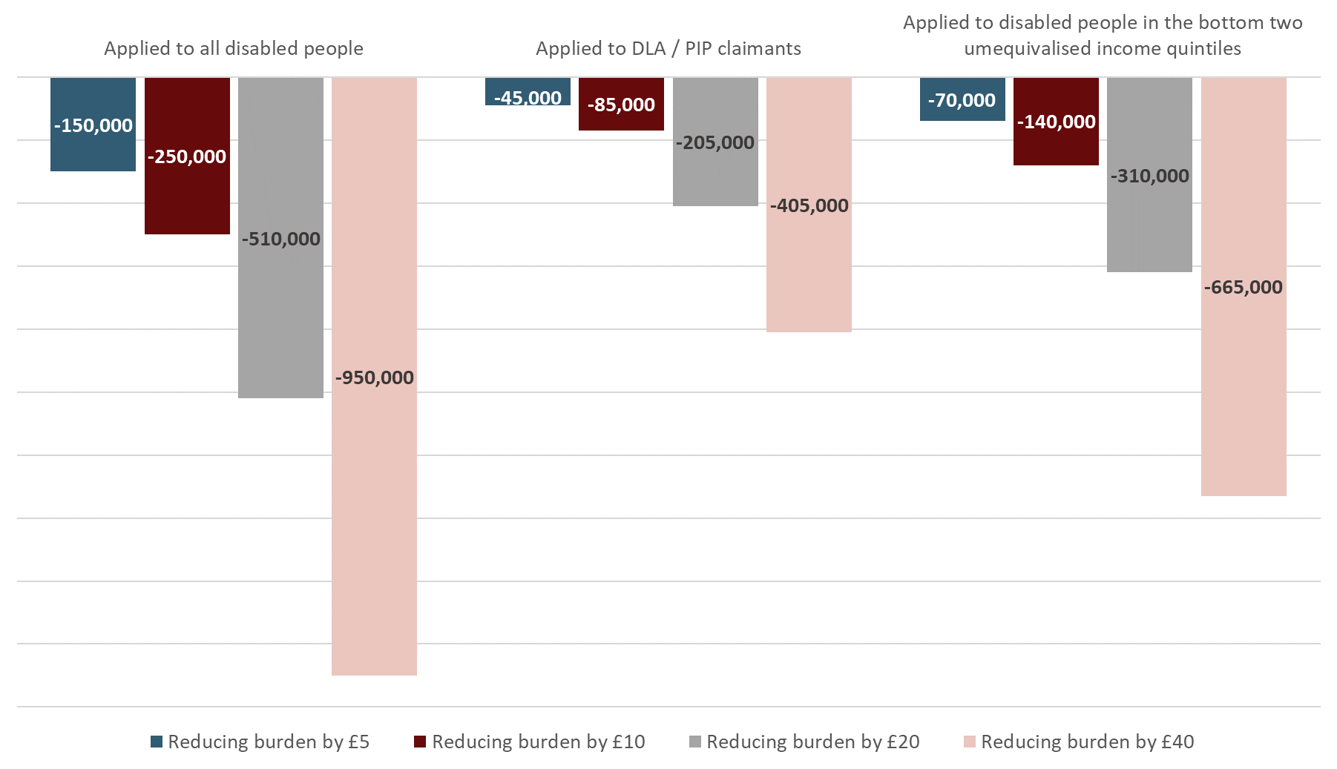
Source: WPI Economics analysis of LCFS & FRS / HBAI.
Notes: Results focus on the impacts of working-age disabled people, disabled children and those living in a family that includes a working-age disabled person or disabled child.

Table 3 shows the total financial gain that each of the scenarios would provide to households that include a disabled person.
There are a range of ways in which each of the scenarios could be delivered and the choice between these would lead to a different allocation of costs between different organisations. For example, scenarios that lead to reductions in the extra burden of essentials faced by DLA / PIP claimants could be delivered through a combination of increased benefit levels and better social tariffs for benefit claimants. This means that, depending on how these were delivered, the costs would likely be shared between government (the increase in benefits) and service providers (e.g. energy providers who are making social tariffs available). Other approaches include investment in improving the energy efficiency of households that include a disabled person. These sorts of approaches would require an upfront investment (presumably at least co-funded by government) for a permanent reduction in energy costs for households that benefit.
Table 3: Total transfer to disabled people that the reduction in the extra burden of essentials would represent (per year; working-age households)
 | Applied to all disabled people | Applied to DLA / PIP claimants | Applied to disabled people in the bottom two unequivalised income quintiles*
£5 reduction | £1.9bn | £0.7bn | £1.0bn
£10 reduction | £3.7bn | £1.4bn | £2.1bn
£20 reduction | £7.5bn | £2.8bn | £4.2bn
£40 reduction | £15.0bn | £5.7bn | £8.4bn
Source: WPI Economics analysis of LCFS & FRS / HBAI
Notes: Results focus on the impacts of working-age disabled people, disabled children and those living in a family that includes a working-age disabled person or disabled child.
*Note that we have assumed this scenario focuses on unequivalised incomes. Whilst basing it on equivalised incomes would more effectively target those most in need, in practice, it would be hard to design a policy intervention that was based on this. In contrast, there is already precedent for basing support on individuals’ or families’ (unequivalised) income levels.

Going beyond the headline poverty impacts, it is also worth considering the broader impacts of the approaches on poverty. One way in which this can be viewed is through an analysis of deep poverty. Figure 7 demonstrates the impacts of each of the scenarios on deep poverty amongst disabled people.
A reduction of £10 per week in the extra burden of essentials faced by disabled people:
- Applied to all disabled people, deep poverty would fall by 180,000.
- Applied to all DLA / PIP claimants, deep poverty would fall by 75,000.
- Applied to all disabled people in the bottom two unequivalised income quintiles, deep poverty would fall by 150,000.
The other scenarios show a similar pattern of results, scaled by the size of the reduction in the extra burden of essentials that has been applied.
What is notable here is that the approach applied to disabled people in the bottom two equivalised income quintiles has a significantly larger proportional impact (compared to poverty impacts) on deep poverty. This is because the measure is specifically targeted on those with lower incomes, rather than either the whole disabled population or DLA / PIP claimants (noting that DLA / PIP claims are not means-tested, so claimants are seen across the income distribution).
Figure 7: Impacts on deep poverty amongst disabled people and those living in a family that includes a disabled people from reducing the extra burden of essentials
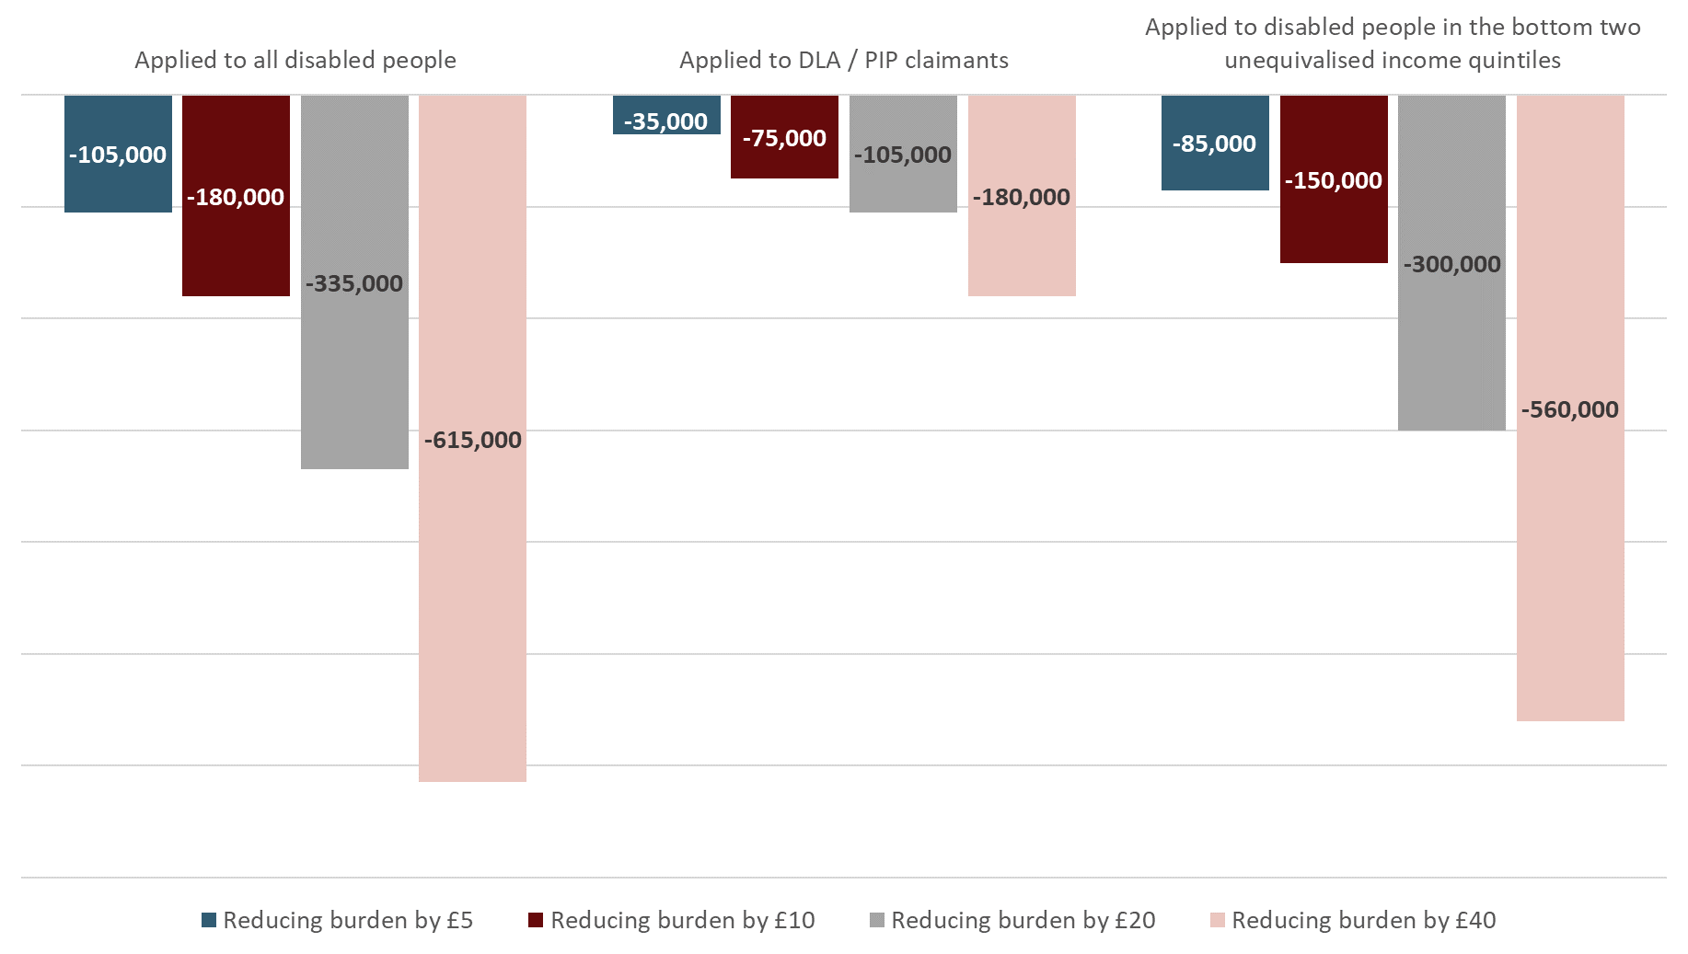
Source: WPI Economics analysis of LCFS & FRS / HBAI.
Notes: Results focus on the impacts of working-age disabled people, disabled children and those living in a family that includes a working-age disabled person or disabled child.

SECTION 5: What does all of this say about how the extra burden of essentials could be most affectively reduced?
The previous section provided headline estimates of the potential impacts of reducing the extra burden of essentials for disabled people and, more generally, approaches that could go further than this and attempt to reduce the overall size of the broader extra costs of disability that disabled people face. This section provides an overview of some of the approaches that might be used to achieve this and the rationale for each approach. Other approaches (for example, direct provision of specific goods and services, or voucher-based schemes) were considered, but viewed as likely to be ineffective or inappropriate.

Increasing Social Security
One of the most obvious levers available would be to increase the value of extra-cost disability benefits (DLA / PIP).
- The existence of an additional burden of essentials amongst disabled people already claiming DLA / PIP suggests that benefit levels are too low to meet the extra costs of essentials that disabled people face. As such, increases in DLA / PIP could rectify this. The results of doing so are demonstrated by the scenarios which target DLA / PIP claimants. Whilst potentially effective at tackling the extra burden of essentials faced by these families, it would not tackle the extra burden of essentials faced by disabled people who do not claim DLA / PIP. This means that other approaches would be needed to reach these families.
- One way of reaching disabled people who do not currently claim DLA / PIP would be to relax the assessment criteria of DLA / PIP. This would bring a larger number of disabled people onto the benefit. Results in this report have shown the extra burden of essentials that this group faces is significantly higher than current payment levels of DLA / PIP. So, to tackle the extra burden of essentials for this group, one could imagine the introduction of a baseline rate of DLA / PIP (perhaps of £5 or £10 per week) available to all disabled people to cover the extra burden of essentials identified here. Alongside this, an assessment would still be needed to judge eligibility for existing elements of DLA / PIP.

Reducing or directly subsidising costs
An alternative (or additional) approach to tackling the additional burden of essentials faced by disabled people would be to reduce the burden directly, by either reducing the cost of essentials faced by disabled people, or the amount that they need to purchase.
There are a range of potential options here:
- Social tariffs are more affordable tariffs targeted at more vulnerable consumers, who may need more of a particular good / service or be less able to pay for the good / service. Examples already exist in water and broadband markets and (voluntarily) from some energy suppliers. Eligibility and available discounts vary across each of the markets / schemes. Some firms will already include disabled people in their definitions of vulnerability, meaning that some disabled people could already have access to social tariffs.
Conceptually, providing a social tariff could be an effective way of tackling the extra burden of energy faced by disabled people. To be effective, careful consideration of the targeting of the approach would be needed. For example, many existing schemes use benefit receipt as a “passport” onto the tariff. We have already shown that many disabled people facing an extra burden of essentials are not in receipt of DLA / PIP, so this sort of mechanism would need to take a broad assessment of benefits, to ensure that those disabled people claiming income replacement benefits (e.g. Universal Credit) are eligible for the scheme, as well as those claiming DLA / PIP.
In terms of potential impact, results above can be used to show that the average extra burden of energy across all households that include at least one disabled person stands at around £6.10 per week – so removing this would most closely align with results of the scenario above that reduces the burden of essentials by £5 per week across all households that include a disabled person (a total reduction in costs across disabled people in working-age households of £1.9bn a year, which results in a reduction of 150,000 people in poverty and 105,000 people in deep poverty).
For those in the bottom two unequivalised income quintiles, the extra burden of energy is between £5.30 (second quintile) and £3.25 (bottom quintile) per week. So, removing this would align with results of the scenario above that reduces the burden of essentials by £5 per week for disabled people in the bottom two unequivalised income quintiles (a total reduction in costs across disabled people in working-age households in the bottom two unequivalised income quintiles of £1.0bn, resulting in a reduction of 70,000 people in poverty and 85,000 people in deep poverty).
Whilst this approach could work well for energy, it is likely to have limited applicability to other areas where disabled people face an extra burden of essentials (e.g. food).
- Home adaptation. Another way in which the extra burden of energy could be reduced is by improving the energy efficiency of disabled peoples’ homes. There is already a policy precedent here, with the Climate Change Committee’s Six Carbon Budget outlining the need to ensure that all properties in the social-rented sector achieve an EPC C rating or better by 2028, in order to be on course for delivering net zero. As well as delivering environmental benefits, estimates suggest that upgrading to an EPC of A, B or C would provide average yearly savings of more than £550 to the occupants of these properties. Given the extra burden of essentials faced by disabled people, it would be natural to ensure that properties occupied by disabled people were prioritised as part of any approach to do this. More generally, there could be a case for additional financial support for retrofitting some properties owned and occupied by lower-income disabled people. Such an approach would help these households to avoid the extra burden of essentials in the longer-term, rather than needing to offer continuous financial support through increased benefits.
Whilst there is a strong case for both a social tariff in energy and support for improving energy efficiency in disabled people’s homes, there are not as many obvious options in other spending categories where disabled people face an extra burden. For example, it is not clear how the extra burden of food spending could be reduced as it would be impossible to operate a social “tariff” (or discount) across so many providers in the market and any attempt to provide in-kind support (e.g. food vouchers) or work with specific suppliers would likely (and rightly) draw criticism for being divisive / stigmatising. This points to the need for some of the extra burden of essentials to be met through the social security system, which can provide the financial support needed, without having to specify exactly where and what the money is spent on.

A package of measures needed
Overall, it is our view that there is not a single policy approach that will be effective in tackling the extra burden of essentials faced by disabled people. Instead, a package of interventions is likely to be needed. This might include the following:
- An essentials payment of £10 per week, paid to disabled people in receipt of any benefit (income based, or extra cost), on top of their existing benefits. This would cost 2.9bn. Should this need to be targeted further, the priority should be those disabled people claiming income-replacement benefits, so that the approach is better targeted at those with the lowest incomes (annual cost of £1.6bn). Alongside this, as part of future work to develop a new assessment process for disability benefits, there could be consideration of whether a lower threshold of disability / impairment might be introduced, which gives more disabled people access to this essentials payment.
- A social tariff for energy for disabled people, like the one already proposed by Scope and other organisations, and linked to a new scheme providing finance and support to fast-track retrofitting of disabled people’s homes and take up of smart technology to improve their energy performance rating in order to reduce energy bills.

Future work
This report highlights new estimates of the extra burden of essentials faced by disabled people and how these might be tackled. There are several ways in which this approach could be taken forward:
- Uprating of benefits. Findings here show that, because disabled people have to spend their money in ways which are systematically different to non-disabled people, they also experience inflation in different ways. For example, overall, we have shown that on average, disabled people would have felt a more significant impact of inflation over the last two years than non-disabled people. This suggests that there could be a case for revising how benefits (particularly those that are meant to cover extra costs) for disabled people are uprated. For example, rather than simply uprating by CPI, this might involve developing a measure of inflation that more closely matches the experiences of disabled people claiming the benefits and using the higher of this, or general CPI to uprate disability-based benefits. This approach could follow a similar approach as that developed by the ONS to create Household Cost Indices for households at different life stages and with different levels of incomes.
- The Social Metrics Commission’s measure of poverty. The findings here suggest that, for those in receipt of DLA / PIP, these benefits are insufficient to ensure that they do not face an extra burden of essentials. They also suggest that those disabled people not claiming DLA / PIP face an additional burden of essentials. Both of these factors suggest that the approach to capturing the extra costs of disability in the SMC’s measure undervalues these costs across the disabled population. As such, there is a strong case for this research to be considered as the DWP take forward its development of the experimental statistics based on the SMC’s approach.

ANNEX 1: Results tables for scenarios for reducing the extra burden of essentials for disabled people and their families
The tables that follow show more detailed results for the scenarios presented in the main body of the report. For each scenario, there is a table for poverty and deep poverty. Each table shows the number of people affected by the change in the extra burden of essentials and the impacts of reducing the burden by £5, £10, £12, £20 and £40 per week.
Scenario 1 (poverty): Impacts on poverty of reducing the extra burden of essentials for all disabled people
Number of disabled people affected by this change | 8,480,000
Number of disabled people and individuals in their families that are affected by the policy | 15,200,000
 | Reducing burden by £5 | Reducing burden by £10 | Reducing burden by £12 | Reducing burden by £20 | Reducing burden by £40
Impact on poverty
All disabled people | -80,000 | -145,000 | -175,000 | -310,000 | -615,000
All disabled people and individuals in their families | -145,000 | -250,000 | -285,000 | -510,000 | -955,000
Disabled - non-benefit-claiming people | -30,000 | -55,000 | -65,000 | -125,000 | -215,000
Disabled - and benefit claimant (DLA / PIP) | -25,000 | -50,000 | -65,000 | -110,000 | -220,000
Disabled people with physical impairments | -40,000 | -75,000 | -90,000 | -150,000 | -320,000
Disabled people with sensory impairments | -10,000 | -25,000 | -30,000 | -40,000 | -80,000
Disabled people with mental and cognitive impairments | -10,000 | -20,000 | -25,000 | -35,000 | -90,000
Disabled people with other type of impairments | -10,000 | -15,000 | -20,000 | -30,000 | -65,000
Source: WPI Economics analysis of LCFS & FRS / HBAI
Notes: Numbers will not sum, as categories are not mutually exclusive.

Scenario 1 (deep poverty): Impacts on deep poverty of reducing the extra burden of essentials for all disabled people
Number of disabled people affected by this change | 8,480,000
Number of disabled people and individuals in their families that are affected by the policy | 15,200,000
 | Reducing burden by £5 | Reducing burden by £10 | Reducing burden by £12 | Reducing burden by £20 | Reducing burden by £40
Impact on poverty
All disabled people | -70,000 | -125,000 | -150,000 | -245,000 | -460,000
All disabled people and individuals in their families | -105,000 | -180,000 | -205,000 | -335,000 | -615,000
Disabled - non-benefit-claiming people | -15,000 | -30,000 | -35,000 | -60,000 | -100,000
Disabled - and benefit claimant (DLA / PIP) | -25,000 | -50,000 | -55,000 | -80,000 | -130,000
Disabled people with physical impairments | -40,000 | -70,000 | -85,000 | -135,000 | -260,000
Disabled people with sensory impairments | -15,000 | -25,000 | -30,000 | -50,000 | -90,000
Disabled people with mental and cognitive impairments | -20,000 | -30,000 | -40,000 | -65,000 | -110,000
Disabled people with other type of impairments | -10,000 | -20,000 | -20,000 | -40,000 | -75,000
Source: WPI Economics analysis of LCFS & FRS / HBAI
Notes: Numbers will not sum, as categories are not mutually exclusive.
Scenario 2 (poverty): Impacts on poverty of reducing the extra burden of essentials for all disabled people who claim DLA / PIP
Number of disabled people affected by this change | 1,860,000
Number of disabled people and individuals in their families that are affected by the policy | 3,460,000
 | Reducing burden by £5 | Reducing burden by £10 | Reducing burden by £12 | Reducing burden by £20 | Reducing burden by £40
Impact on poverty
All disabled people | -30,000 | -60,000 | -80,000 | -130,000 | -255,000
All disabled people and individuals in their families | -45,000 | -85,000 | -115,000 | -205,000 | -405,000
Disabled - non-benefit-claiming people | 0 | 0 | 0 | 0 | 0
Disabled - and benefit claimant (DLA / PIP) | -30,000 | -60,000 | -80,000 | -130,000 | -255,000
Disabled people with physical impairments | -30,000 | -50,000 | -65,000 | -105,000 | -210,000
Disabled people with sensory impairments | -5,000 | -15,000 | -20,000 | -25,000 | -50,000
Disabled people with mental and cognitive impairments | -5,000 | -15,000 | -15,000 | -25,000 | -60,000
Disabled people with other type of impairments | -5,000 | -5,000 | -5,000 | -10,000 | -30,000

Source: WPI Economics analysis of LCFS & FRS / HBAI
Notes: Numbers will not sum, as categories are not mutually exclusive.

Scenario 2 (deep poverty): Impacts on deep poverty of reducing the extra burden of essentials for all disabled people who claim DLA / PIP
Number of disabled people affected by this change | 1,860,000
Number of disabled people and individuals in their families that are affected by the policy | 3,460,000
 | Reducing burden by £5 | Reducing burden by £10 | Reducing burden by £12 | Reducing burden by £20 | Reducing burden by £40
Impact on poverty
All disabled people | -25,000 | -50,000 | -55,000 | -85,000 | -135,000
All disabled people and individuals in their families | -35,000 | -70,000 | -80,000 | -105,000 | -180,000
Disabled - non-benefit-claiming people | 0 | 0 | 0 | 0 | 0
Disabled - and benefit claimant (DLA / PIP) | -25,000 | -50,000 | -55,000 | -85,000 | -135,000
Disabled people with physical impairments | -15,000 | -40,000 | -40,000 | -65,000 | -110,000
Disabled people with sensory impairments | -5,000 | -10,000 | -10,000 | -20,000 | -30,000
Disabled people with mental and cognitive impairments | -10,000 | -15,000 | -20,000 | -30,000 | -50,000
Disabled people with other type of impairments | 0 | -10,000 | -15,000 | -20,000 | -30,000
Source: WPI Economics analysis of LCFS & FRS / HBAI
Notes: Numbers will not sum, as categories are not mutually exclusive.
Scenario 3 (poverty): Impacts on poverty of reducing the extra burden of essentials for disabled people in the bottom two unequivalised income quintiles
Number of disabled people affected by this change | 4,490,000
Number of disabled people and individuals in their families that are affected by the policy | 6,410,000
 | Reducing burden by £5 | Reducing burden by £10 | Reducing burden by £12 | Reducing burden by £20 | Reducing burden by £40
Impact on poverty
All disabled people | -50,000 | -95,000 | -130,000 | -225,000 | -490,000
All disabled people and individuals in their families | -70,000 | -140,000 | -180,000 | -310,000 | -655,000
Disabled - non-benefit-claiming people | -15,000 | -30,000 | -35,000 | -70,000 | -155,000
Disabled - and benefit claimant (DLA / PIP) | -20,000 | -40,000 | -50,000 | -95,000 | -190,000
Disabled people with physical impairments | -35,000 | -60,000 | -70,000 | -125,000 | -275,000
Disabled people with sensory impairments | -10,000 | -20,000 | -30,000 | -40,000 | -75,000
Disabled people with mental and cognitive impairments | -10,000 | -20,000 | -25,000 | -35,000 | -85,000
Disabled people with other type of impairments | -5,000 | -10,000 | -10,000 | -15,000 | -45,000
Source: WPI Economics analysis of LCFS & FRS / HBAI
Notes: Numbers will not sum, as categories are not mutually exclusive.
Scenario 3 (deep poverty): Impacts on deep poverty of reducing the extra burden of essentials for disabled people in the bottom two unequivalised income quintiles
Number of disabled people affected by this change | 4,490,000
Number of disabled people and individuals in their families that are affected by the policy | 6,410,000
 | Reducing burden by £5 | Reducing burden by £10 | Reducing burden by £12 | Reducing burden by £20 | Reducing burden by £40
Impact on poverty
All disabled people | -70,000 | -115,000 | -140,000 | -240,000 | -445,000
All disabled people and individuals in their families | -85,000 | -150,000 | -175,000 | -300,000 | -560,000
Disabled - non-benefit-claiming people | -15,000 | -25,000 | -30,000 | -50,000 | -90,000
Disabled - and benefit claimant (DLA / PIP) | -25,000 | -50,000 | -55,000 | -80,000 | -130,000
Disabled people with physical impairments | -40,000 | -70,000 | -80,000 | -135,000 | -255,000
Disabled people with sensory impairments | -15,000 | -25,000 | -30,000 | -50,000 | -85,000
Disabled people with mental and cognitive impairments | -20,000 | -30,000 | -40,000 | -65,000 | -110,000
Disabled people with other type of impairments | -5,000 | -15,000 | -20,000 | -35,000 | -75,000
Source: WPI Economics analysis of LCFS & FRS / HBAI
Notes: Numbers will not sum, as categories are not mutually exclusive.

ANNEX 2: Technical documentation

Glossary
Disabled person | As defined by the Equalities Act
Households that includes a disabled person | A household that includes at least one member that is disabled as per the Equalities Act definition
Income-based benefits | Means tested social security benefits, for example Employment and Support Allowance (ESA), Universal Credit (UC).
Extra burden of essentials | Differentials of spending budget shares on essential household goods and services
Extra costs | The additional amount of income to compensate disabled households to have the same standard of living as equivalent non-disabled households.
Extra cost benefits | Benefits (typically non-means tested) that are provided to cover the extra costs of disability (e.g. Disability Living Allowance (DLA), Personal Independence Payment (PIP)).
Extra cost of disability | The conceptual extra cost on disabled people's lives, including financial burden, accessibility issues and toll of extra effort.
COICOP | Classification of Individual Consumption According to Purpose
CPI/CPIH | Consumer Price Index/Consumer Price Index incl. Owner Occupiers’ Housing Costs
DWP | Department for Work and Pensions
FRS | Family Resources Survey
GDP | Gross Domestic Product
LCF | Living Costs and Food Survey
NatCen | National Centre for Social Research
ONS | Office for National Statistics
Poverty line | The level of Total Resources Available below which families are judged to be in poverty. This is based on the Social Metrics Commission’s approach to poverty measurement.
Deep poverty line | The level of Total Resources Available below which families are judged to be in deep poverty. This is 50% of the poverty line and is based on the Social Metrics Commission’s approach to poverty measurement.
SMC | Social Metrics Commission
UK | United Kingdom

Overview
Overall, our approach followed the following process:
- Calculating the extra burden of essentials for disabled people:
- Calculate the proportion of total spending that is allocated to essentials for households within the Living Costs and Food Survey in 2019/20.
- Assess the extent to which households that include a disabled person experience an extra burden of essentials, by running regression analysis to take into account differences in characteristics.
- Translate these into financial terms, using estimates of mean spending at each income quintile.
- Analyse the inflation impact on disabled people of inflation rates between 2019/20 and July 2023, using detailed inflation rates for different spending categories and applying these to spending baskets from 2019/20.
- Estimate up-to-date extra burden of essentials by applying differential in disabled people’s inflation impact and the headline CPI inflation rate.
- Calculating poverty impacts
- Match these estimates into the Family Resources Survey / HBAI based on disability status and income quintile.
- Conduct analysis of poverty impacts in the FRS / HBAI using an adapted version of the Social Metrics Commission’s poverty measure.

Calculating the extra burden of essentials

Living Costs and Food Survey
In order to understand the expenditure patterns of households that do and do not include a disabled person, we used the Living Costs and Food Survey (LCFS). The LCFS is an annual UK household survey conducted by the Office for National Statistics (ONS) that collects detailed information on household expenditure. Outputs produced from it are designated as a National Statistics and data collected feeds into CPI and GDP figures.
The survey takes place throughout the year to account for any seasonal variations in expenditure. Individuals in selected households complete a household interview and keep an expenditure diary for two weeks. The household interview collects information on income, sociodemographic characteristics and expenditure information on big items and one-off purchases (appliances, cars etc). It also asks about benefits, disability and other personal information. Participants use the expenditure diary to record any item they purchase over the two-week period.
Expenditure is expressed as pounds per week and products and services that make up people’s expenditure are categorised, using the Classification of Individual Consumption According to Purpose (COICOP). COICOP is an international classification system for individual household expenditure. It is hierarchical, with four levels, which get progressively more detailed. For our current analysis, we used the highest level, which classifies all items and services into 12 groups. We disaggregated two of these groups into categories that we wanted to explore further, so in total we analysed 14 groups (see Table A1).
Table A1: COICOP categories used in our analyses.
01 Food and non-alcoholic beverages
02 Alcoholic beverages, tobacco and narcotics
03 Clothing and footwear
4 Housing excluding energy bills
4.5 Energy bills
05 Furnishings, household equipment and routine household maintenance
06 Health
7 Transport excl. private car hire (taxis etc.)
7.3.5 Taxis and hired cars with drivers
08 Communication
09 Recreation and culture
10 Education
11 Restaurants and hotels
12 Miscellaneous goods and services

Defining disability in the Living Costs and Food Survey
We used the harmonised standard measurement of disability for the Equality Act, 2010, as provided by the ONS. This classifies individuals as disabled if they have had a physical or mental health condition lasting over 12 months, which has reduced their ability to carry out daily activities. The same definition was used to define disability in the FRS. Households with at least one person, over 17 years old, self-reporting disability were classed as disabled.
42% of participants in the UK self-reported disability to the LCF. This breaks down to 41% in England and 46% in Wales. Compared to the 2021 Census figures for England and Wales, it appears that the LCF overestimates self-reported disability. Table A2 shows the comparison between the LCFS the 2021 census and the FRS.
Table A2: Self-reported disability for England and Wales in the LCF and the 2021 census.
 | Percentage of households with at least one disabled person
 | LCFS | Census 2021 | FRS
England | 41% | 32% | 40%
Wales | 46% | 38% | 50%
We also wanted to explore how results might vary across different groups of disabled people. However, the available variables in the LCFS limited the extent to which we were able to do this. One way we could assess this was to look at the number of disabled people that lived in each household and the different benefits that disabled people within each household received. We were particularly interested in understanding whether the provision of extra costs benefits successfully met any extra burden of essentials that we identified. As such, we split household benefit claims into three categories – households claiming no benefits, households claiming income-based benefits only and households claiming benefits including an extra cost benefit. Table A3 shows the benefits we included in each category.

Table A3: Benefits included in each of the two categories
Income-based benefits | Extra costs benefits
Working Tax Credits | DLA (self-care, mobility or both)
Employment Support Allowance | PIP - care part (daily living)
Severe Disablement Allowance | PIP - mobility part
Incapacity benefit | Attendance allowance
Industrial injury disablement benefit
Universal Credit
Jobseeker’s Allowance
Council Tax disability reduction

We were then able to classify households into 7 mutually exclusive categories based on the number of disabled people in a household and the type of benefits that people in the household receive:
- Household with no disabled people;
- Households with one disabled person, not claiming benefits;
- Households with one disabled person, claiming benefits only income-based benefits;
- Households with one disabled person, claiming benefits including an extra cost benefit;
- Households with multiple disabled people, not claiming benefits;
- Households with multiple disabled people, claiming benefits only income-based benefits; and
- Households with multiple disabled people, claiming benefits including an extra cost benefit.

Calculating the proportion of spending that goes on essentials
We used an alternative, aggregate classification in order to help us understand patterns better. This classifies products and services as essential or non-essential and has been created by the Australian Bureau of Statistics. It does not map directly to the COICOP categories shown here but happens at a more detailed level - this means that most COICOP categories shown here contain a mix of essential and non-essential items. For example, all basic food items in the 01 Food and non-alcoholic beverages are considered essential, while cakes and confectionery from the same overall category are considered non-essential. The exception is 04 Housing and 06 Health; all items in those categories are considered essential.
Note that where we assess the proportions of spending that is allocated to essential items and undertake regression analysis to estimate the extra burden of essentials, we focus on an after-housing-costs measure. This removes rent and mortgage payments from the calculation. We have done this for two key reasons:
- The Social Metrics Commission’s measure of poverty (which we use to assess the impact of the extra burden of essentials on poverty - see below) is an after–housing-costs measure, so we needed an after-housing-costs measure of the extra burden of essentials to incorporate into this framework.
- Aside from this, the reported values of spending on rent and mortgages in the LCF are significantly different between disabled and non-disabled people, because of the prevalence of social-rented accommodation and housing benefit claims amongst the disabled people.

Calculating the extra burden of essentials
Of course, while these figures are interesting, it is likely that households that do and do not include disabled people have different levels of income and differing characteristics (for example in terms of family size and composition and age) and that these will affect their expenditure choices. For example, table A4 shows that households with at least one disabled member are more likely to have lower incomes than those without any disabled members.
Table A4: Weighted number (%) of disabled and non-disabled households in each equivalised income quintile
 | 1 - lowest incomes | 2 | 3 | 4 | 5 – highest incomes
Household disability | Number of households (% of households)
No disability | 7,311 (44) | 8,183 (50) | 9,818 (60) | 10,712 (65) | 12,180 (74)
Household with disability | 9,172 (56) | 8,297 (50) | 6,662 (40) | 5,773 (35) | 4,293 (26)

Therefore, in order to obtain more robust estimates of the differences in proportional spending on essentials (“the extra burden of essentials”) between households that do and do not include a disabled person, we use multivariate regression analysis to capture and control for differences in income, household composition, geography and other demographic characteristics. This allows us to compare “like-for-like”. Although it is impossible to take all household differences into account, we have tried to capture as many observable characteristics as possible.
We use three waves of the LCFS in our analysis in order to maximise the explanatory power of our regression model. These are the three years prior to the pandemic (2017/18, 2018/19, 2019/20) as years with lockdowns affected spending patterns. For example, expenditure on recreational and leisure activities was much lower in the 2020/21 wave than previous waves. This means that we are not using the latest data but the most representative data. There were a total of 16,318 households in our unweighted, multi-year sample.
We estimated a standard multivariate linear regression, where the outcome variable is proportional expenditure on essentials and the main predictor of interest is an indicator variable that categorises household disability status across six distinct levels (see above), plus an additional base-level for non-disabled households. To capture and control for further differences between households, we also included the following as additional factorial covariates in our model:
- Unequivalised household net income quintile
- Age band of the head of the household
- Ethnicity of the head of the household
- Sex of the head of the household
- Number of adults in the household
- Number of children in the household
- Household tenure type
- Region
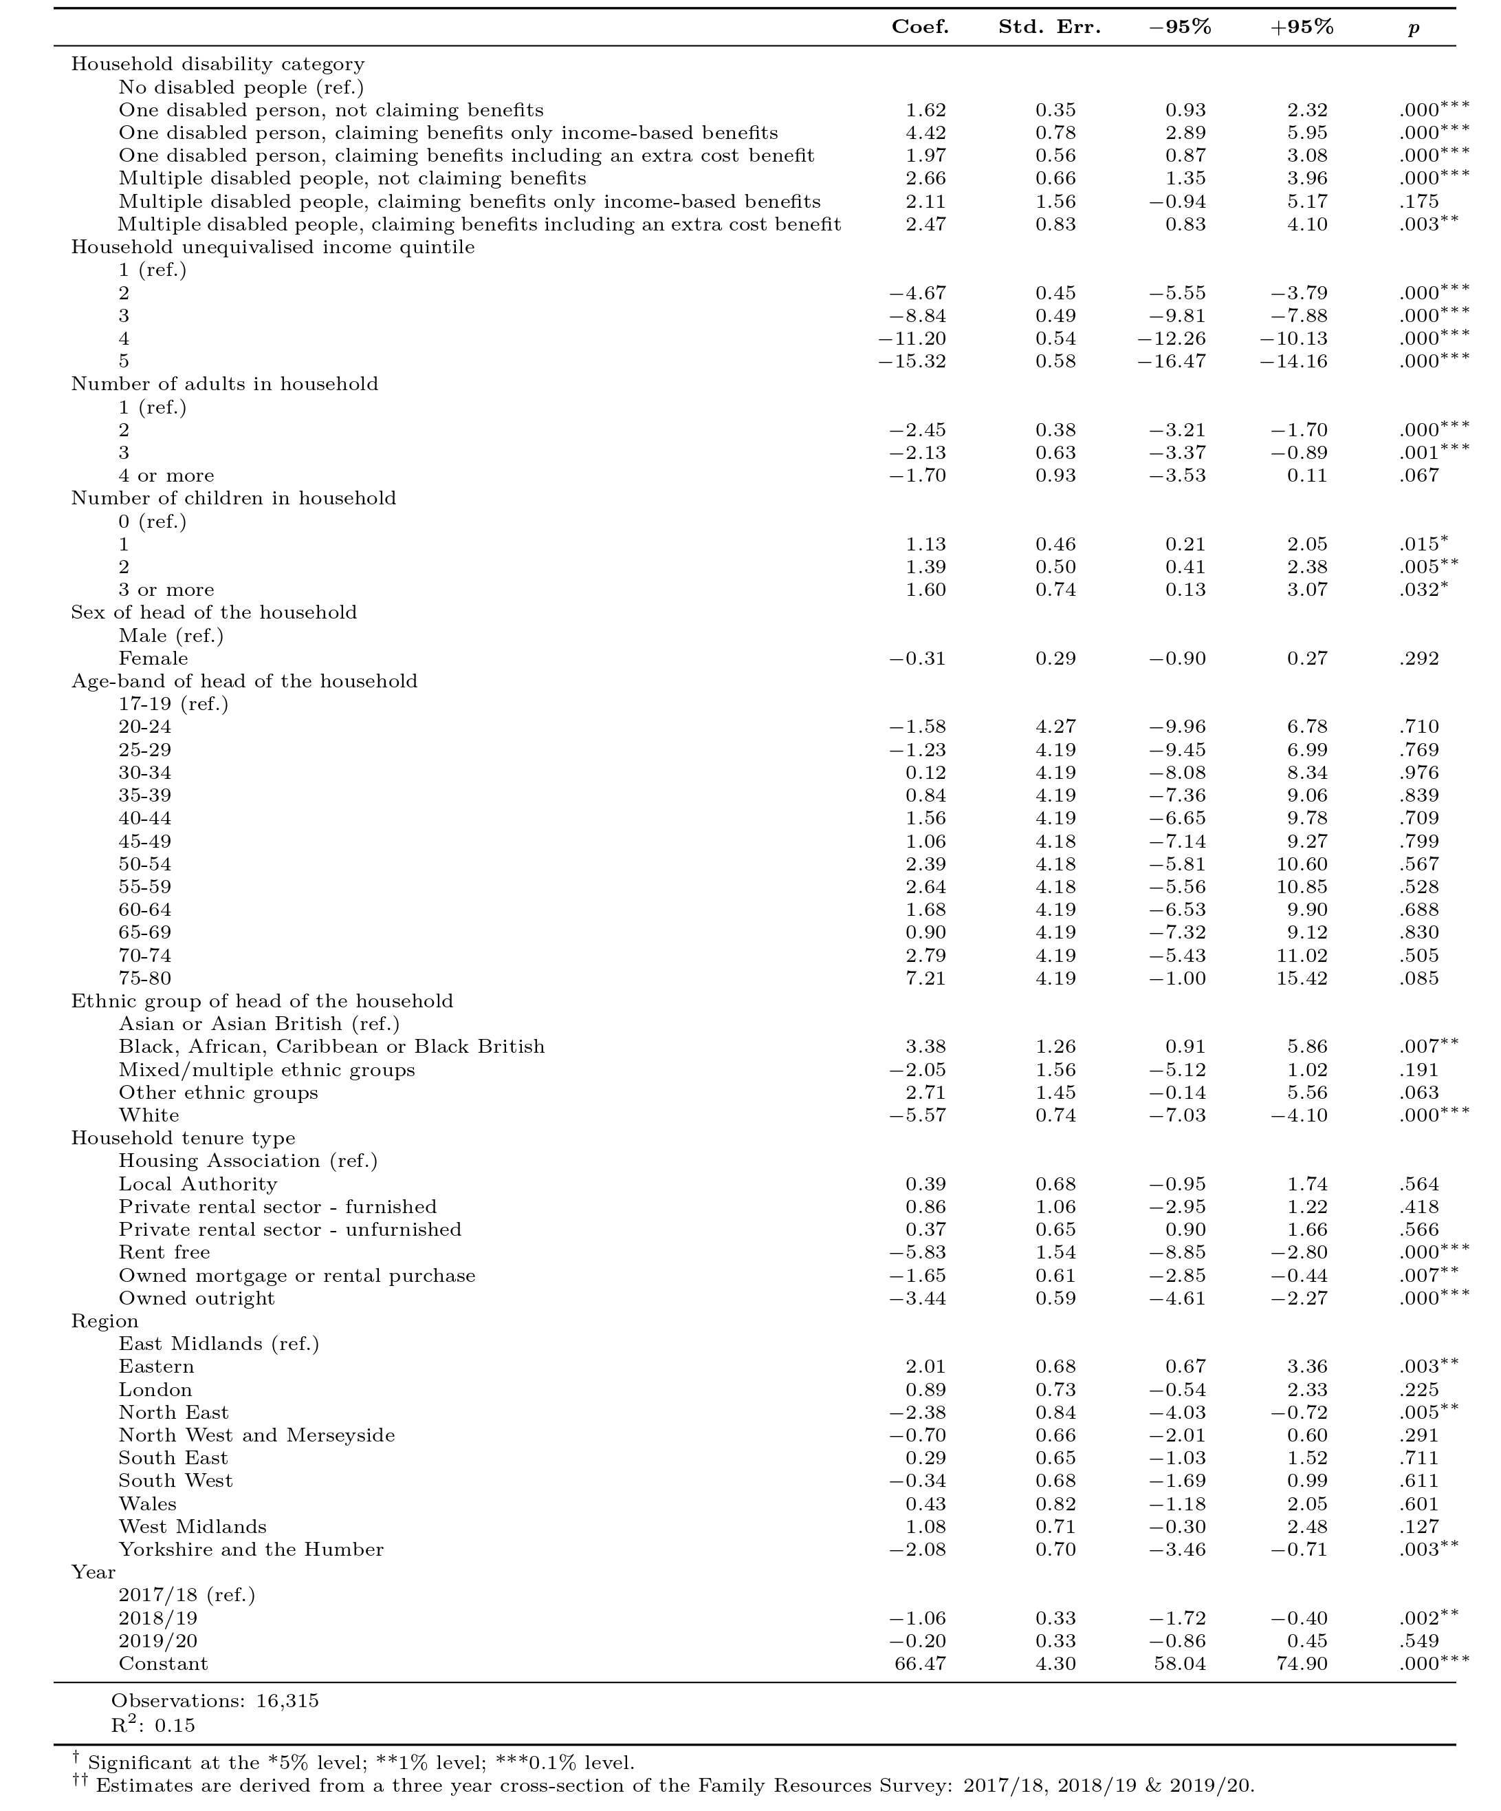
We also included an additional year indicator variable in our model to control for temporal variation within our multi-year sample. Due to missing values, three households are dropped from the regression, resulting in a sample 16,315 households.

We then multiplied the coefficient for each disability category by the full-sample mean of total household expenditure by (unequivalised) income quintile. The result is an estimate of the ‘extra burden on essentials’ for disabled households at five equidistant points in the income distribution. These figures were then updated to account for the impact of differential inflation impacts experienced be households that include a disabled person, since 2019/20.

Calculating the inflation impact on disabled people
This part of the analysis explores what the impact of inflation would be if households were to have the same level of spending now, as they did during the baseline period of 2017/2020 (the years from which we drew our household expenditure estimates). As such, it gives an indication of what impact inflation has had on the ability of households to maintain the same standard of living. It is not an inflation measure in itself but tells us the effect that inflation has had on specific baskets of goods and services, that is, how much the prices that consumers pay for a specific shopping basket have changed over the last three years and whether these price changes affect disabled and non-disabled households in different ways.
In order to calculate the impact of inflation, we used the LCFS expenditure estimates and the disaggregated index of CPIH inflation produced by the ONS, which tracks price changes for each COICOP category, at the second most disaggregated level. The ONS publishes the CPIH index based in 2015 - we rebased this to the dates of our baseline expenditure estimates (2017 Q2 to 2020 Q1). We calculated the price changes between our baseline and most recent inflation figures to date for each of the COICOP categories and then we summed these up to classify them as essential or non-essential expenditures. These gives us the percentage by which the price of essential and non-essential items have increased since 2020 for disabled and non-disabled households.
One thing to keep in mind is that consumers likely change their behaviour when prices change. This means that the shopping basket of 2017-2020 will not be the same as the shopping basket today since many consumers will have made different choices in response to price rises. The analysis therefore cannot give us an exact picture of households’ current expenditure nor can it tell us how this has changed due to high inflation. However, the analysis provides a useful reference point and contributes to our understanding of the impact of inflationary pressures on household spending in general, and on disabled households more specifically.
Calculating the poverty impacts of the extra burden of essentials
The basis of this approach is to match in estimates of the extra burden of essentials from the analysis above into the FRS / HBAI and apply the Social Metrics Commission’s measure of poverty, adapted to include the extra burden of essentials.

Family Resources Survey
The Family Resources Survey (FRS) is an annual UK household survey on living standards carried out in Great Britain since 1992 and the UK since 2003. It is jointly run by the Office for National Statistics, the National Centre for Social Research (NatCen) and the Department for Work and Pensions (DWP) and produces National Statistics.
The survey collects data on income, housing tenure, disability, savings, caring responsibilities and pensions. Its primary objective is to provide information to the DWP in order to develop, monitor and evaluate social welfare policy. The survey contributes data to the national accounts and migration statistics.

Social Metrics Commission poverty measure
The Social Metrics Commission (SMC) was founded in 2016 to develop a new way of measuring poverty in the UK that is not solely based on income. This measure takes into account a wider set of material resources available to a household as well as ”inescapable costs”, such as childcare and housing costs and the extra costs of disability. In addition it takes a broader approach and includes household overcrowding and sleeping rough. Figure A1 shows how the headline measure of resources available to the family is constructed.
The approach then takes this headline measure of “total resources available” and judges people to be in poverty if they are in a family that has less than three-year rolling average of 54% of the equivalised median value of total resources available. This threshold value was set to ensure that the SMC measure produced broadly similar numbers of people in poverty as the Household Below Average Income relative-income measure of poverty in 2016/17.
Of particular relevance to this project is the fact that the SMC measure incorporates a consideration of the extra costs of disability. At the time of publication, the SMC noted that, while a significant improvement on other measures of poverty, its approach was a relatively crude one as it simply assumed that the extra costs of disability were equal to the extra cost benefits that disabled people reported to claim. In practice, this means that extra cost benefits are assumed not to contribute to the resources that disabled people have available to meet their day-to-day needs. This makes sense, as these benefits are intended to pay for “extra costs”, rather than meet day-to-day needs. However, the approach also means that no households are judged to have extra costs that exceed the value of DLA / PIP and that disabled people that do not claim DLA / PIP are assumed to have no extra costs. In all likelihood, neither of these things will be true and that is one of the key things explored in this project.
Figure A1: Social Metrics Commission framework for measuring poverty
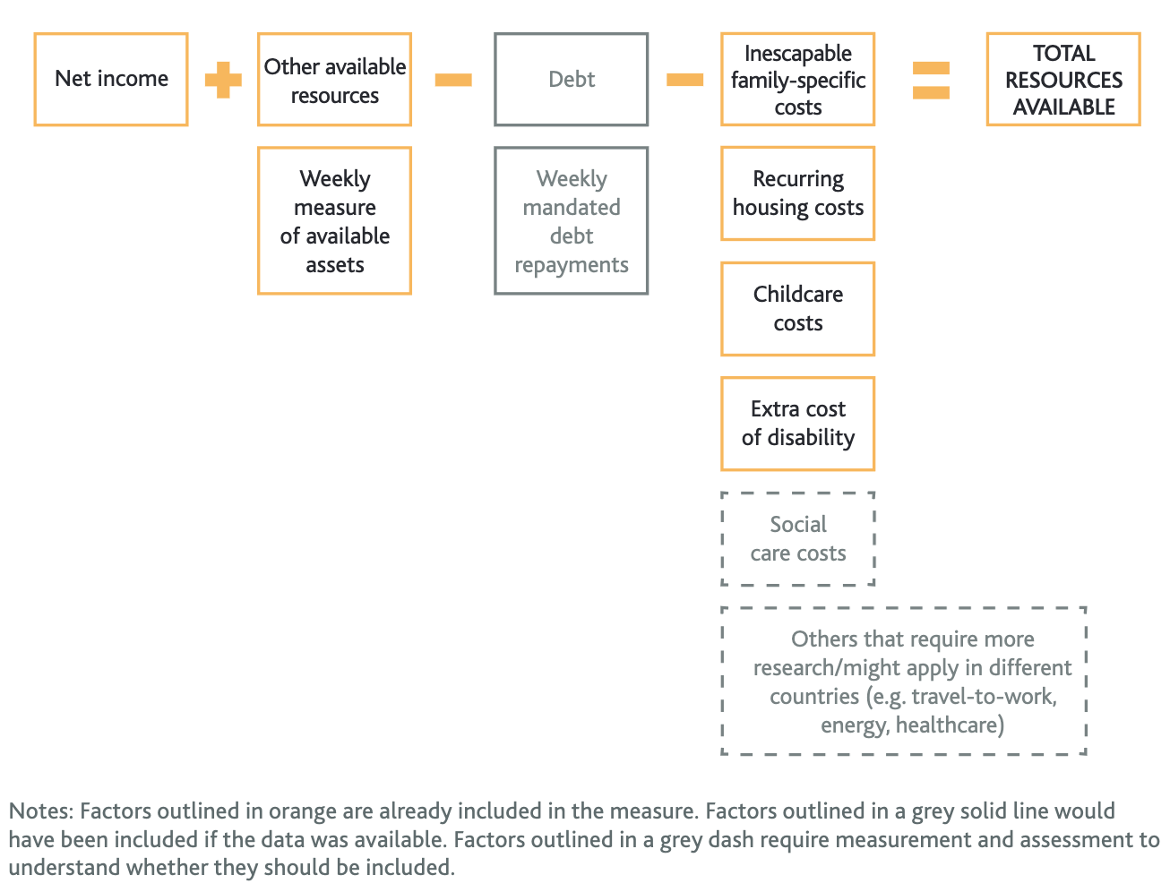
Based on the results from the LCFS analysis of the extra burden of essentials, we added the financial value of this to the “extra cost of disability” element of TRA. This means that, for those claiming DLA / PIP, their extra costs are now higher than the extra income they receive from the benefits. For those disabled people not claiming DLA / PIP - they are now assumed to have some level of additional costs.

FRS matching process
We operationalised this approach by matching the values of the extra burden of essentials into the FRS / HBAI. We first identified households based on the number of disabled people within them, whether they claimed benefits and the broad type of benefit claimed (to match our approach in the LCFS, outlined above). One slight departure from the LCFS categorisation concerns the treatment of extra cost benefits claimed by children. The LCFS does not provide information on child-based benefits claims, and so the categorisation of disabled households is based exclusively on benefit claims made by adults. The FRS, however, does provide information on child-based extra cost disability benefit claims (Disability Living Allowance for children). We therefore decided to incorporate this additional information in our categorisation of disabled households in FRS in order to better capture the experiences of child disability and its impact on the household. We then merged our matrix of LCFS-derived estimates of the ‘extra burden on essentials’ into FRS according to household disability status and income quintile. For households that do not include a disabled person, the value of the ‘extra burden on essentials’ is set to 0.

Modelling the poverty impact of the extra burden of essentials
The values for the extra burden of essentials are matched into the Family Resources Survey for the financial year 2019/20, as outlined above, at the level of the household.
These values are then allocated from the household level to the level of the benefit unit (“family”), according to the disability status of families within the household. For example, if there are two families within a household and only one includes a disabled person, then the family that includes a disabled person will be allocated the extra burden of essentials. Where two or more families that include a disabled person are present in the same household, the burden of essentials is allocated according to relative equivalisation factors, using the modified OECD equivalisation scale. Note that, for the purpose of this analysis, SMC poverty has been calculated at the level of the benefit unit.
For families in receipt of DLA or PIP, the measure of the extra burden of essentials is considered as the additional extra burden after DLA / PIP has ameliorated some of the total extra burden. In other words, without DLA / PIP, estimates of the extra burdens would likely be higher still. For those families who do not receive DLA or PIP, but that include a disabled person, their extra burden of essentials of disability is assumed to equal the burden of essentials.
In both cases, in the financial year 2019/20, the SMC’s measure of available resources, “total resources available” (TRA), is reduced by the value of the extra burden of essentials. The in-year, equivalised TRA median for the financial year 2019/20 is then recalculated to account for the reductions in TRA experienced by families that include a disabled person.
The SMC’s approach uses a smoothed poverty line. To create this, the in-year TRA medians for the financial years 2018/19 and 2017/18 are averaged to calculate the poverty line and deep poverty line.
Poverty status and deep poverty status are then calculated based on these poverty lines. The difference between these poverty estimates, updated to account for the extra burden of essentials, and pre-existing poverty estimates is given as the poverty impact of the extra burden of essentials experienced by disabled people.

Modelling options for alleviating the extra burden of essentials
The analysis continues by considering how the poverty impact of the extra burden of essentials might be alleviated by increasing the resources available to disabled people. In line with the SMC framework, this increase in resources could be affected either by increasing disabled peoples’ incomes (for example, through the social security system) or by reducing the costs that they face. Three scenarios are considered. In each, resources are increased for some families that include a disabled person, relative to a baseline incorporating the extra burden of essentials (see above). Increases of £5, £10, £12, £20, and £40 are modelled for each scenario.
In the first scenario, all families that include a disabled person receive an increase in their resources. This includes families with disabled children, with disabled working-age adults, or with disabled pensioners. For the purposes of this analysis, a person is considered disabled if they self-reported disability, according to the core definition of the Equality Act 2010. All families that include disabled people - including those that include more than one disabled person - receive an increase in their resources only once.
In the second, all people who are in receipt of the extra cost benefits Disability Living Allowance (DLA) and Personal Independence Payment (PIP), and who live in a family that includes a disabled person, see an increase in their resources. This includes all claimants, including: pensioners who are in receipt of a claim made before they reached the state pension age; and children in receipt of Disability Living Allowance (DLA) for children. Note that if a person is in receipt of DLA/PIP but does not self-report disability under the core definition of the Equality Act 2010 (and none of the other people in their family self-reports disability) then they will not receive an increase in resources. Also note that, for this scenario, increases in resources are applied at the level of the individual claimant. So, if a family includes two people in receipt of DLA/PIP then this family will receive any increase twice.
In the third scenario, families that include a disabled person, who are in the bottom two quintiles of the income distribution, receive an increase in their resources. The relevant income quintiles are defined using gross, un-equivalised, benefit unit income. As in previous scenarios, a person is considered disabled if they self-reported disability, according to the core definition of the Equality Act 2010.
Note that, for all scenarios, reporting is for working families (i.e., excluding pensioner families). This includes both estimates of poverty impacts and estimates of the scale of total transfers.
DATA USED IN THIS BRIEFING
Living Costs and Food Survey
Office for National Statistics. (2019). Living Costs and Food Survey. [data series]. 3rd Release. UK Data Service. SN: 2000028, DOI:
Family Resources Survey
Department for Work and Pensions, Office for National Statistics, NatCen Social Research. (2023). Family Resources Survey, 2019-2020. [data collection]. UK Data Service. SN: 8802
Department for Work and Pensions, Office for National Statistics, NatCen Social Research. (2023). Family Resources Survey, 2018-2019. [data collection]. UK Data Service. SN: 8633
Department for Work and Pensions, Office for National Statistics, NatCen Social Research. (2023). Family Resources Survey, 2017-2018. [data collection]. UK Data Service. SN: 8460
Households Below Average Income
Department for Work and Pensions. (2023). Households Below Average Income, 1994/95-2021/22. [data collection]. 17th Edition. UK Data Service. SN: 5828

ENDNOTES

Note here that a family is considered to be in poverty if the level of their available resources, defined according to the SMC framework, is below 54% of the population-level median (the poverty line). They are considered to be in deep poverty if the level of their resources is below 27% of the population-level median (the deep poverty line). All families that are in deep poverty are also in poverty. When looking at the impact of specific reforms, it is possible to reduce the level of deep poverty without affecting the overall level of poverty if families move above the deep poverty line but do not move out of poverty entirely.
Note here that a family is considered to be in poverty if the level of their available resources, defined according to the SMC framework, is below 54% of the population-level median (the poverty line). They are considered to be in deep poverty if the level of their resources is below 27% of the population-level median (the deep poverty line). All families that are in deep poverty are also in poverty. When looking at the impact of specific reforms, it is possible to reduce the level of deep poverty without affecting the overall level of poverty if families move above the deep poverty line but do not move out of poverty entirely.
Defined here according to the SMC’s measure of deep poverty, which represents those that are more than 50% below the poverty line, thereby indicating extreme levels of hardship.
Note that we do not believe it would be practical to offer support for retrofit in the private-rented sector, as landlords would benefit (rather than tenants) and there is no guarantee that the disabled person would remain in the same property.
Low income refers to a household in the bottom equivalised income quintile.
A range of different measures of poverty, disadvantage or deprivation could have been used in this report. The SMC measure of poverty is used as it allows us to assess the impacts of the extra costs of disability. See Annex for a more detailed explanation of the methodology.
See https://www.scope.org.uk/campaigns/extra-costs/disability-price-tag-2023/ . Accessed 09/01/2024.
This figure, and those poverty estimates that follow, refers to working-age households only.
For example see here https://www.scope.org.uk/campaigns/extra-costs/disability-price-tag-2023/ , including sources from technical report.
See for example, https://www.which.co.uk/news/article/travel-insurance-market-still-not-working-for-customers-with-medical-conditions-which-research-finds-atUyc0T8SGN1 and https://www.bbc.co.uk/news/disability-66177998 .
https://socialmetricscommission.org.uk/measuring-poverty-before-the-covid-19-pandemic/
For example, see https://www.economicsobservatory.com/how-is-the-cost-of-living-crisis-affecting-disabled-people-in-the-uk and https://www.scope.org.uk/news-and-stories/cost-of-living-disabled-people/
https://www.scope.org.uk/campaigns/extra-costs/disability-price-tag-2023/
Office for National Statistics. (2019). Living Costs and Food Survey. [data series]. 3rd Release. UK Data Service. SN: 2000028, DOI: http://doi.org/10.5255/UKDA-Series-2000028
Equivalised income takes account of family size and composition, allowing us to compare like for like.
See https://www.abs.gov.au/statistics/research/non-discretionary-and-discretionary-inflation Accessed 09/01/2024.
See https://www.scope.org.uk/campaigns/extra-costs/disability-price-tag-2023/ Accessed 09/01/2024.
See https://www.gov.uk/government/statistics/development-of-a-new-measure-of-poverty-statistical-notice Accessed 09/01/2024.
See https://socialmetricscommission.org.uk/social-metrics-commission-2018-report/ Accessed 09/01/2024.
See https://www.gov.uk/government/collections/households-below-average-income-hbai--2 Accessed 09/01/2024.
See https://www.smf.co.uk/publications/social-housing-regeneration/ Accessed 09/01/2024.
See https://ifs.org.uk/publications/poverty-chapter Accessed 09/01/2024.
See https://www.ons.gov.uk/economy/inflationandpriceindices/bulletins/householdcostsindicesforukhouseholdgroups/january2022toseptember2023#household-costs-indices-for-other-subgroups Accessed 09/01/2024.

